A PROJECT REPORT

ON

EV BMS WITH CHARGE MONITOR AND FIRE PROTECTION

## CONTENTS

**ABSTRACT**

**CHAPTER-1: PAGE NO**

[INTRODUCTION](#_TOC_250014)  7

[CHAPTER-2:](#_TOC_250013)

[PROBLEM IDENTIFICATION](#_TOC_250012) 9

[CHAPTER-3:](#_TOC_250011)

SPECIFICATION DEVELOPMENT 11

[CHAPTER-4:](#_TOC_250006)

CONCEPTUAL DESIGN 13

CHAPTER-5

DETAIL DESIGN 14

CONCLUSION 15

REFERENCES 16

**LIST OF FIGURES**

|  |  |  |
| --- | --- | --- |
| **S. No.** | **Name of the figure** | **Page No.** |
| 1 | Block diagram of Battery Management System | 13 |
| 2 | Battery Voltage over Time | 15 |
| 3 | Current at Different States | 16 |
| 4 | Final Design | 17 |

**ABSTRACT**

Electric vehicles (EVs) are rapidly becoming a cornerstone of sustainable transportation, thanks to their ability to reduce carbon emissions and reliance on fossil fuels. However, the technology behind EVs, particularly regarding battery management, has yet to reach its full potential in terms of efficiency and safety. Battery-related incidents, such as fires and reduced operational lifespan, are significant concerns that undermine user confidence and hinder the widespread adoption of EVs.

This project presents an innovative solution in the form of an Electric Vehicle Battery Management System (BMS) with integrated charge monitoring and fire protection. The system employs an advanced STM32 microcontroller to continuously monitor crucial battery parameters including voltage, current, and temperature. This real-time monitoring allows the system to take pre-emptive actions, such as cutting off the power supply, to prevent hazardous situations like overcharging, over-discharging, and overheating.

Our BMS features a user-friendly interface with an LCD display that provides real-time updates on the battery’s status. This ensures that users are always informed about the battery’s condition, enhancing both safety and convenience. By implementing precise control over the battery’s charging and discharging processes, the system not only extends the battery’s lifespan but also optimizes its performance, ensuring efficient energy utilization.

**CHAPTER-1**

##### INTRODUCTION

Electric vehicles represent a transformative shift in the automotive industry, offering a viable path towards reducing greenhouse gas emissions and curbing the dependence on non-renewable energy sources. Despite the promising future of EVs, the technology faces several critical challenges, particularly in the realm of battery management. Incidents of battery fires and degradation highlight the need for more robust and reliable battery management systems.

The core of any EV is its battery, and its performance directly influences the vehicle's efficiency, safety, and overall user experience. Current battery management solutions often fall short in addressing the myriad issues associated with battery safety and longevity. This project aims to bridge that gap by developing a comprehensive Battery Management System (BMS) that not only monitors but also protects the battery through real-time data analysis and automatic intervention.

Our BMS is designed to tackle the pressing issues of overcharging, overheating, and premature battery wear, which are common in the existing EV market. By leveraging advanced sensor technology and a powerful STM32 microcontroller, our system offers a sophisticated solution that enhances battery safety and performance. The user interface, featuring an LCD display, ensures ease of use and accessibility, providing real-time feedback to users about the battery's status and any potential issues.

In this report, we delve into the various aspects of our project, from problem identification and specification development to conceptual and detailed design. Each section provides a comprehensive overview of the methodologies employed, the technologies used, and the benefits of our BMS solution. By the end of this report, we hope to demonstrate the efficacy of our system and its potential impact on the EV industry.

##### CHAPTER-2

##### PROBLEM IDENTIFICATION

##### The rapid expansion of the electric vehicle market has brought to light several critical issues related to battery safety and efficiency. One of the most pressing concerns is the occurrence of battery fires, often caused by overcharging, overheating, or internal short circuits. These incidents not only pose a significant safety risk but also undermine consumer confidence in electric vehicles, hindering their adoption on a broader scale.

Moreover, the longevity of EV batteries is a persistent issue. Frequent overcharging and improper battery management can lead to accelerated degradation, reducing the battery's effective lifespan and, consequently, the vehicle's overall performance. Users often experience anxiety related to the reliability and safety of their EV batteries, which affects their willingness to adopt and trust this technology.

Our project aims to address these concerns by developing an advanced Battery Management System (BMS) that provides comprehensive monitoring and protection for EV batteries. The system is designed to detect and mitigate potential hazards in real-time, ensuring that the battery operates within safe parameters at all times. By doing so, we aim to enhance the safety, reliability, and longevity of EV batteries, ultimately fostering greater user confidence and supporting the growth of sustainable transportation.

Additionally, the current market offers several BMS solutions, but many of these systems lack the necessary features to provide robust protection and monitoring. Existing solutions often fail to accurately monitor critical parameters or respond promptly to dangerous conditions, leading to increased risks and reduced battery performance. Our system addresses these shortcomings by incorporating high-precision sensors and advanced control algorithms, ensuring that the battery is protected under all operating conditions.

In summary, the main problems we aim to solve are:

1. **Battery Fires and Safety Risks**: Preventing incidents caused by overcharging, overheating, and other hazardous conditions.
2. **Battery Longevity**: Extending the lifespan of EV batteries through precise control of charging and discharging processes.
3. **User Confidence**: Enhancing trust in EV technology by providing reliable and comprehensive battery protection.

Through our innovative BMS, we hope to contribute to a safer, more efficient, and more reliable future for electric vehicles.

##### CHAPTER-3

##### SPECIFICATION DEVELOPMENT

* Software requirements
* Hardware components

The development of a robust and reliable Battery Management System (BMS) for electric vehicles requires careful consideration of both general and technical specifications. These specifications ensure that the system meets the necessary safety, performance, and user interface requirements to effectively manage and protect EV batteries.

**Purpose**: The primary purpose of our BMS is to monitor, charge, and protect a 3S Li-ion battery pack used in electric vehicles. The system aims to ensure safety and efficiency by continuously monitoring battery parameters and taking appropriate actions to prevent potential hazards such as overcharging, over-discharging, and overheating.

**System Functionality**:

1. **Real-time Monitoring**: The system continuously monitors the battery's voltage, current, and temperature using high-precision sensors.
2. **Automatic Cutoff**: If any parameter exceeds safe limits, the system automatically cuts off the input or output power to prevent damage or hazardous conditions.
3. **User Alerts**: The system provides real-time alerts and status updates through an LCD display, ensuring that users are always informed about the battery's condition.

**User Interface**:

1. **LCD Display**: A character LCD display provides real-time battery status information and system alerts.
2. **Switches and LED Indicators**: These components allow for user interaction and provide visual status indicators.

**Compatibility**: The system is designed to be compatible with 3S Li-ion battery packs commonly used in electric vehicles. It ensures seamless integration with existing EV systems and components.

**Integration**: All components are integrated into a compact and robust system suitable for installation in various electric vehicle models. The design ensures ease of installation and maintenance.

**Technical Specifications**:

1. **Microcontroller**: STM32 for data processing and interfacing with sensors and user interface components.
2. **Temperature Sensor**:
   * Range: -20°C to 80°C
   * High accuracy to ensure reliable temperature monitoring.
3. **Voltage Sensor**:
   * Range: 9V to 12.6V
   * Fine resolution for precise voltage measurement.
4. **Current Sensor**:
   * Adequate range to cover typical EV battery currents.
   * High accuracy for reliable current monitoring.
5. **LCD Display**:
   * Character LCD compatible with STM32.
   * Backlight for visibility in various lighting conditions.
6. **Li-ion Battery**:
   * Configuration: 3S (three cells in series)
   * Nominal Voltage: 11.1V
   * Built-in protection for safety and reliability.
7. **Regulatory Circuitry**:
   * Voltage regulators to ensure stable power supply.
   * Current limiters to prevent overcurrent conditions.
   * Temperature monitoring to protect against overheating.
8. **Interface Components**:
   * Switches for user input.
   * LED Indicators for visual status updates.
9. **Power Supply**:
   * Typically 12V with sufficient current capacity to power the system.
10. **Dimensions and Mounting**:
    * Compact design with mounting holes or brackets for easy installation in various EV models.

By adhering to these specifications, our BMS ensures optimal performance, safety, and user satisfaction. The system is designed to meet the evolving needs of the electric vehicle industry, providing a reliable solution for battery management and protection.

##### CHAPTER-4

##### CONCEPTUAL DESIGN

The conceptual design of our Electric Vehicle Battery Management System (BMS) is focused on achieving proactive safety, optimized performance, and user-friendly operation. Central to this design is the utilization of advanced sensors and an STM32 microcontroller, which together form the backbone of our monitoring and control system.

**Core Components**:

1. **STM32 Microcontroller**:
   * The STM32 microcontroller is responsible for data processing and executing control logic. It interfaces with various sensors to gather real-time data on battery parameters such as voltage, current, and temperature.
2. **Sensors**:
   * **Temperature Sensor**: Monitors the temperature of the battery pack, ensuring it operates within safe limits. The sensor's high accuracy and wide operating range (-20°C to 80°C) make it suitable for various environmental conditions.
   * **Voltage Sensor**: Measures the voltage of the 3S Li-ion battery pack with fine resolution, ensuring precise monitoring and control.
   * **Current Sensor**: Tracks the current flow to and from the battery, providing crucial data for preventing overcurrent conditions and optimizing charging and discharging processes.
3. **User Interface**:
   * **LCD Display**: A character LCD provides real-time updates on battery status, including voltage, current, temperature, and system alerts. The backlight feature ensures visibility under different lighting conditions.
   * **Switches and LED Indicators**: These components allow for user interaction and provide visual feedback on the system's status. Switches can be used to control various functions, while LEDs indicate operating conditions and alerts.

**System Architecture**: The BMS architecture is designed to be modular and scalable, allowing for easy integration into different electric vehicle models. The core processing unit (STM32 microcontroller) is at the heart of the system, interfacing with sensors and the user interface. This modularity ensures that the system can be easily adapted to different battery configurations and vehicle requirements.

**Real-Time Monitoring and Control**: The system continuously monitors battery parameters through its sensors. Data is processed in real-time by the STM32 microcontroller, which analyzes the information to detect any anomalies or unsafe conditions. If any parameter exceeds predefined safe limits, the system automatically initiates protective measures, such as cutting off the power supply to prevent overcharging, over-discharging, or overheating.

**Safety Features**:

1. **Automatic Cutoff**: The system can disconnect the battery from the charging or discharging circuit if unsafe conditions are detected.
2. **Alerts and Notifications**: Real-time alerts are displayed on the LCD, and LEDs provide visual indications of the system's status. This ensures that users are promptly informed of any issues.
3. **Fail-Safe Mechanisms**: The system includes redundancy in critical components to ensure reliable operation even in the event of a component failure.

**User-Friendly Interface**: The user interface is designed to be intuitive and easy to use. The LCD display provides clear and concise information about the battery's status, while switches and LEDs offer straightforward control and feedback. This design ensures that users can easily monitor and manage their EV's battery, enhancing the overall user experience.

**Integration and Compatibility**: The BMS is designed to be compatible with standard 3S Li-ion battery packs and can be integrated into various electric vehicle models. The system's compact design and flexible mounting options ensure that it can be easily installed and maintained.

In summary, the conceptual design of our BMS focuses on providing a comprehensive solution for monitoring and protecting EV batteries. By leveraging advanced sensors and a powerful microcontroller, the system ensures real-time safety and performance optimization, ultimately contributing to the reliability and adoption of electric vehicles.

##### bms_block_diagram.png

##### CHAPTER-5

##### DETAIL DESIGN

The detailed design of our Electric Vehicle Battery Management System (BMS) encompasses the integration of hardware components, the development of control algorithms, and the design of the user interface. Each component is selected and configured to ensure optimal performance, safety, and user convenience.

**Hardware Components**:

1. **STM32 Microcontroller**:
   * The STM32 microcontroller is the central processing unit of the BMS. It is chosen for its high processing power, low power consumption, and extensive peripheral support. The microcontroller interfaces with sensors, the LCD display, and other components to perform real-time data processing and control tasks.
2. **Temperature Sensor**:
   * The temperature sensor is crucial for monitoring the battery's thermal state. We use a high-accuracy sensor with a wide operating range (-20°C to 80°C) to
   * ensure reliable temperature readings under various conditions. The sensor is placed close to the battery cells to provide accurate temperature data.
3. **Voltage Sensor**:
   * The voltage sensor measures the voltage of the 3S Li-ion battery pack. It provides fine resolution and high accuracy, ensuring precise monitoring. The sensor is connected to the battery terminals and interfaced with the STM32 microcontroller for real-time data acquisition.
4. **Current Sensor**:
   * The current sensor tracks the current flow to and from the battery. It is essential for detecting overcurrent conditions and optimizing the charging and discharging processes. The sensor's high accuracy and adequate range ensure reliable current measurements.
5. **LCD Display**:
   * The character LCD display provides real-time updates on the battery's status, including voltage, current, temperature, and system alerts. It is interfaced with the STM32 microcontroller, which sends data to be displayed. The backlight feature ensures visibility in different lighting conditions.
6. **User Interface Components**:
   * **Switches**: Used for user inputs, allowing control over various functions of the BMS.
   * **LED Indicators**: Provide visual feedback on the system's status, such as power on/off, charging/discharging state, and alerts.

**System Integration**: The integration of hardware components is done on a custom-designed PCB (Printed Circuit Board) that houses the STM32 microcontroller, sensors, display, and interface components. The PCB is designed to ensure minimal signal interference and optimal layout for efficient operation.

**Control Algorithms**:

1. **Real-Time Monitoring**:
   * The STM32 microcontroller continuously collects data from the sensors. The control algorithms process this data in real-time to monitor the battery's status.

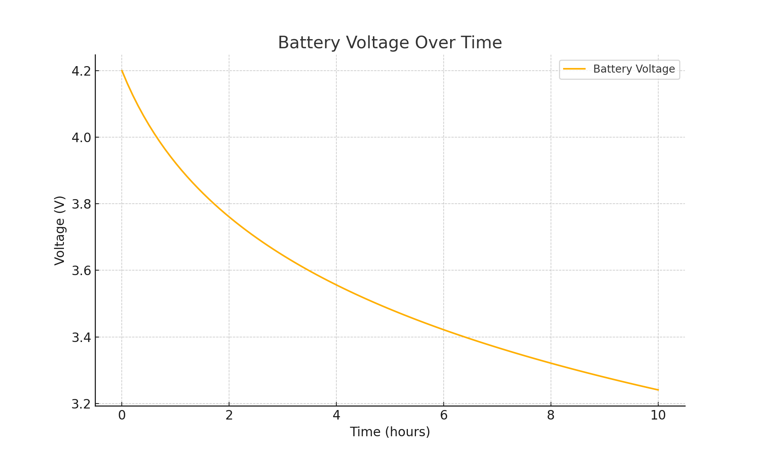

1. **Safety Mechanisms**:
   * If the temperature, voltage, or current exceeds predefined safe limits, the control algorithms trigger protective actions, such as disconnecting the battery from the circuit.
2. **Charging and Discharging Control**:
   * The system regulates the charging and discharging processes to optimize battery performance and extend its lifespan. This includes preventing overcharging and over-discharging, which can damage the battery.

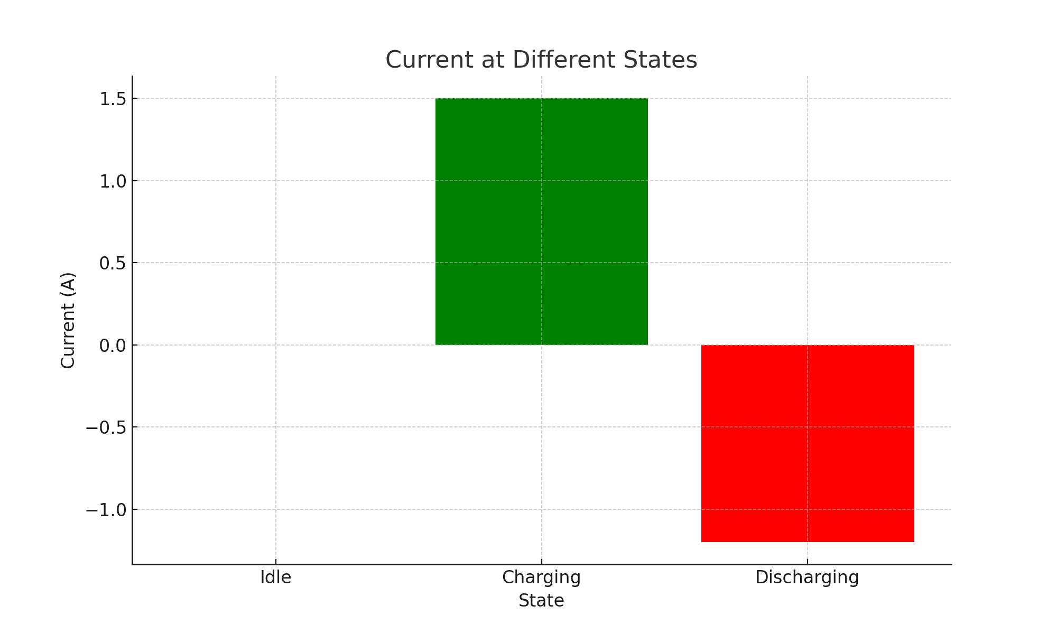

1. **User Alerts**:
   * The control algorithms manage the LCD display and LED indicators to provide real-time feedback and alerts to the user. This ensures that users are promptly informed about the battery's status and any potential issues.

**User Interface Design**: The user interface is designed to be intuitive and user-friendly. The LCD display provides clear and concise information about the battery's status, while switches and LEDs offer straightforward control and feedback. This design ensures that users can easily monitor and manage their EV's battery, enhancing the overall user experience.

**Testing and Validation**:

1. **Component Testing**:
   * Each hardware component is individually tested to ensure proper functionality and accuracy. This includes testing the sensors, microcontroller, display, and interface components.
2. **System Integration Testing**:
   * The integrated system is tested to ensure that all components work together seamlessly. This includes verifying the real-time monitoring and control functionalities.
3. **Safety and Reliability Testing**:
   * The BMS is subjected to various stress tests to ensure its reliability and safety under different operating conditions. This includes testing for overcharging, over-discharging, and thermal protection.

**Final Assembly**: The final assembly involves mounting the PCB and other components into a compact enclosure that protects the system from environmental factors and ensures ease of installation in electric vehicles. The enclosure is designed to provide adequate ventilation and access to user interface components.

By meticulously designing and integrating each component, we ensure that our BMS provides a reliable, safe, and user-friendly solution for electric vehicle battery management. The detailed design process highlights our commitment to quality and innovation, ultimately contributing to the advancement of electric vehicle technology.

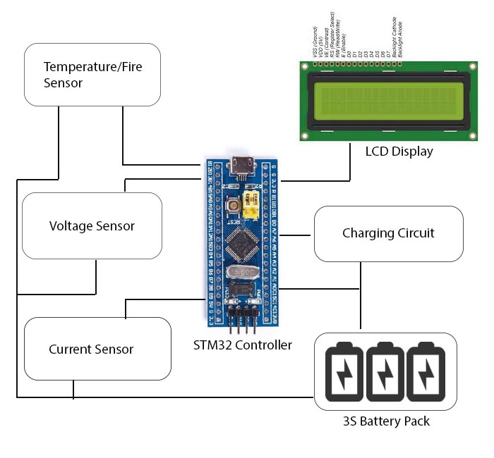

CONCLUSION

In conclusion, our Electric Vehicle Battery Management System (BMS) represents a significant advancement in the field of electric vehicle technology. By addressing the critical issues of battery safety, efficiency, and longevity, our system provides a comprehensive solution that enhances the overall performance and reliability of EVs.

**Enhanced Safety**: One of the primary objectives of our BMS is to improve the safety of electric vehicle batteries. The system's real-time monitoring and automatic cutoff mechanisms effectively prevent hazardous conditions such as overcharging, over-discharging, and overheating. By ensuring that the battery operates within safe parameters, our BMS reduces the risk of battery fires and other safety incidents, ultimately protecting both the vehicle and its occupants.

**Optimized Performance**: Our BMS also optimizes the performance of the battery by carefully regulating the charging and discharging processes. This not only extends the battery's lifespan but also ensures efficient energy utilization, resulting in better overall vehicle performance. Users can rely on their EVs for longer periods without worrying about frequent battery replacements or performance degradation.

**User Confidence and Adoption**: By providing reliable and comprehensive battery management, our BMS enhances user confidence in electric vehicle technology. The user-friendly interface, featuring an LCD display and intuitive controls, ensures that users are always informed about the battery's status and any potential issues. This transparency and ease of use foster greater trust in EV technology, encouraging more users to adopt electric vehicles as a sustainable mode of transportation.

**Contribution to Sustainable Transportation**: Our project aligns with the broader goal of promoting sustainable transportation. By improving the safety and efficiency of electric vehicles, we contribute to reducing greenhouse gas emissions and decreasing reliance on fossil fuels. Our BMS supports the transition to cleaner and more sustainable energy sources, helping to address the pressing environmental challenges of our time.

**Future Prospects**: The successful development and implementation of our BMS open up numerous possibilities for future research and innovation. Future work could focus on further enhancing the system's capabilities, such as integrating advanced machine learning algorithms for predictive maintenance and developing more compact and cost-effective designs. Additionally, our BMS can be adapted for use in other applications, such as renewable energy storage systems and portable electronic devices.

**Acknowledgements**: We extend our heartfelt thanks to our internal guide Surendar Bandi for the technical guidance, constant encouragement, and enormous support provided throughout the project. We also appreciate the valuable insights and feedback from our peers and faculty members, which have been instrumental in refining our project.

In summary, our Electric Vehicle Battery Management System addresses the critical needs of safety, efficiency, and user confidence in the EV industry. Through innovative design and meticulous engineering, we have developed a solution that promises to make electric vehicles safer, more reliable, and more appealing to users, thereby contributing to the growth of sustainable transportation.

##### REFERENCES

* + [**Temperature Overcharge and Short-Circuit Studies of Batteries Used in Electric Vehicles**](https://www.researchgate.net/profile/Andrzej-Lebkowski/publication/316171277_Temperature_Overcharge_and_Short-Circuit_Studies_of_Batteries_used_in_Electric_Vehicles/links/59035e750f7e9bc0d58d7050/Temperature-Overcharge-and-Short-Circuit-Studies-of-Batteries-used-in-Electric-Vehicles.pdf)
  + **Design and Development of Battery Management System for Electric Vehicles**
  + **Understanding Electric Vehicle Battery Management Systems**
  + [**Battery Management Systems for Electric Vehicles**](https://www.springer.com/gp/book/9783030174090)
  + **Electric Vehicle Battery Thermal Management**
  + **Battery Management System (BMS) for Electric Vehicles**

##### Electric Vehicle Battery Safety